Image | Source | Why I chose the image:
 | https://www.color-hex.com/color-palette/2280 | Possible colour scheme.
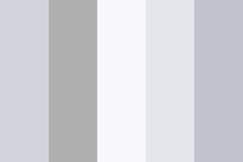 | https://www.color-hex.com/color-palette/425 | Possible colour scheme.  I chose these colours as I don’t want my magazine to be overloaded with colour, the greys will lower the tone of the magazine as the audience is your young adults nit children.
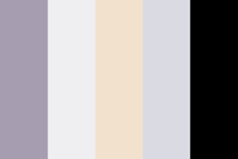 | https://www.color-hex.com/color-palette/194 | Possible colour scheme.
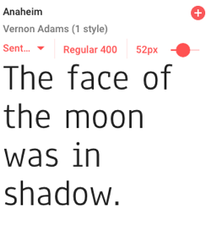 | https://fonts.google.com/specimen/Anaheim | Font style inspiration.  I would use this font on lighter backgrounds
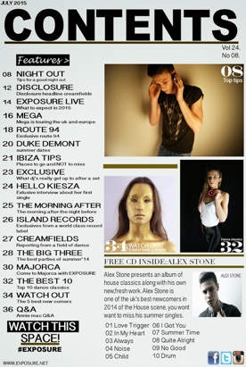 | http://lndgcsemediaassignment3.blogspot.com/2016/08/examples-of-magazine-contents-pages.html | I like the style of this contents page and the layout. The listing of the pages is all uniformed which makes it look more appealing to the eye.  I also like how for some of the pages the have just put the artist and a page number.
 | http://www.acpme.ac.uk/index.php/41-2-2/ | I have put this image on my mood board as I like the layout of the spread, using the shapes and colours. I love the choice of using one bold colour and then black and white as it compliments that colour.
 | https://fonts.google.com/specimen/Heebo | Font style inspiration.  If I was to use this style of text it would be for a title as its bold and would stand out, catching the readers attention.
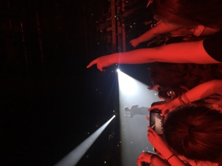 | Original photo I have taken | I took this image when I was at the Vamps concert. I think I might use this image as my front cover and use bold white text.
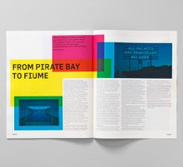 | https://fonts.google.com/specimen/Heebo | I have chosen this picture because I liked the idea of the layering with the different colours and the spread look simple, modern and stands out.
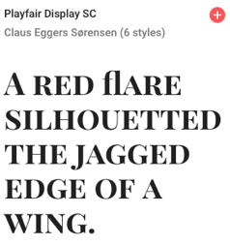 | https://fonts.google.com/specimen/Playfair+Display+SC | Font style inspiration.  This is another font style that I am considering to use for titles as its bold and stands out.
 | https://coolors.co/2e3951-ed6a5a-f4f1bb-9bc1bc-e6ebe0 | Possible colour scheme.
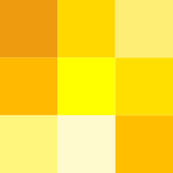 | https://en.wiktionary.org/wiki/yellow | Possible colour scheme.
 | https://en.wikipedia.org/wiki/Shades_of_red | Possible colour scheme.  The red colours go with my cover picture so I might have my colour theme as red as it will look uniformed.

